National Council of Faculty Senates approves constitution and by-laws and elects officers
Austin, Texas — October 19, 2019 — At the 2nd Annual Meeting of the National Council of Faculty Senates (NCFS), faculty members from universities from across the country gathered and ratified the organizational documents to start a national faculty governance organization.
The body then solicited nominations for the officer positions of president, vice president, secretary, and treasurer. The attendees nominated and chose Trevor Hale (Texas A&M University) as President, Gwen Kay (State University of New York System) as Vice-president, Martha Horst (Illinois State University) as Treasurer, and Diane Henshel (Indiana University) as Secretary. The Executive Committee’s first order of business is to re-organize and re-populate the standing committees of the NCFS. The NCFS plans to host their first convention during 2020 to bring together faculty governance leaders from across the country.
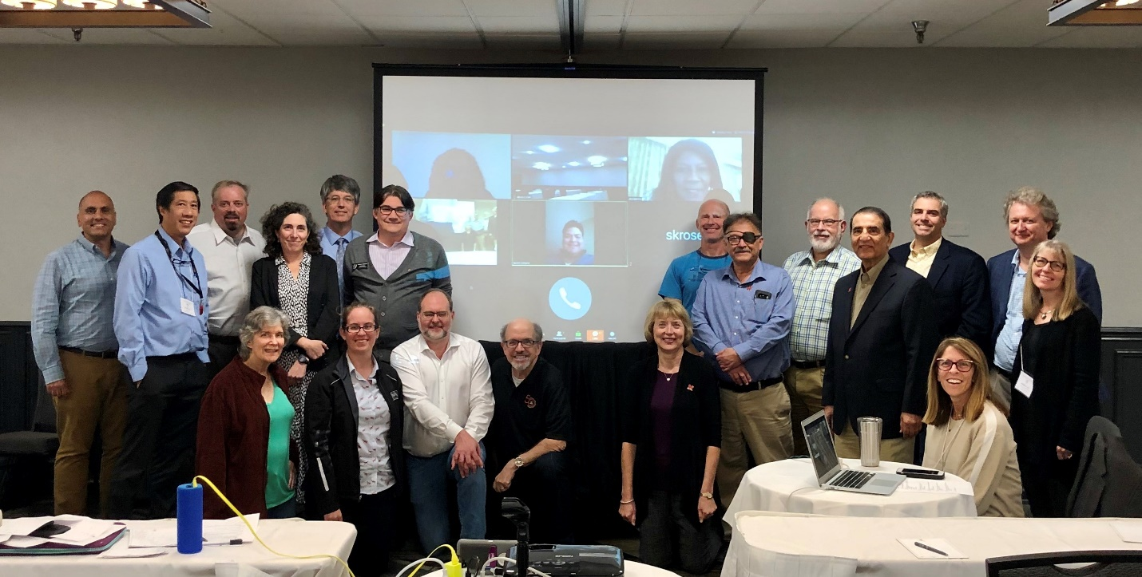
Faculty in Austin, Texas for the 2nd Annual National Council of Faculty Senates Meeting

For more information: Anand Rao <arao@umw.edu>

